AIRPLANE CRASH ANALYSIS

INTRODUCTION;

When a major air line disaster occurs, the federal government provides support services to the families of victims and to survivors.

Mechanical failure has always been a reason for plane crash, sometime it has been listened that the engines stop working or there is some failure in the plane.

If these problems are identified while in a flight then there is no prevention and automatically leads to plane crash.

Most airplane crashes are caused by one or more of the following:

* Pilot error,
* Defective equipment,
* Defective design or structural problem with the plane,
* Faulty maintenance or repair of the airplane, and
* Fuel problem.

Advantages and disadvantages of airway:

Advantages:

* Fastest mode of transport.
* Cheaper infrastructure than rail or road.
* Air travel is strategically significant.
* Free from geographic barriers like hills and lakes.
* Useful during natural disaster.

Disadvantages:

* High operational costs.
* Air transport accidents are usually fatal.
* Huge initial investment.
* Difficult to carry very large cargo.
* Affected by bad weather.

Empathy map:

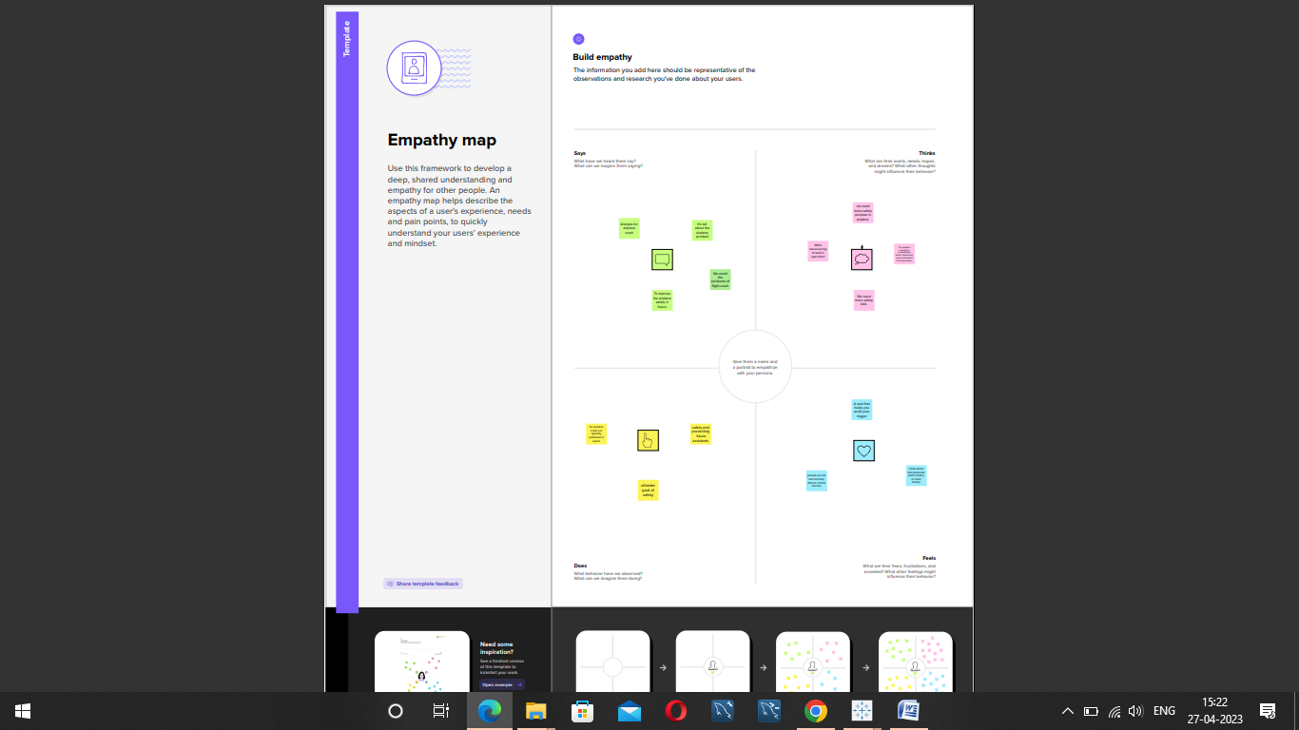

Brainstorming:

Result:

Dashboard:

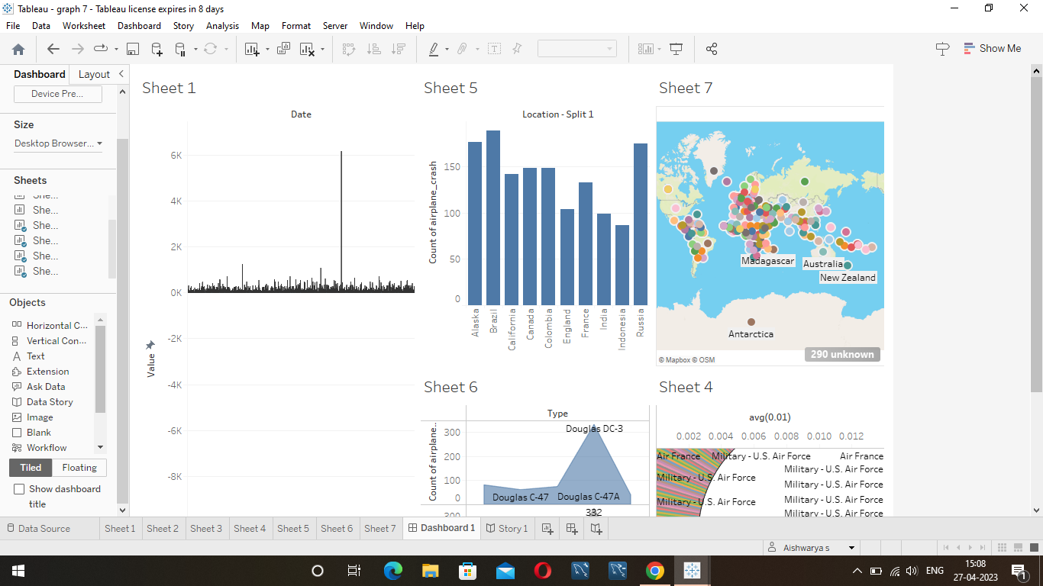

Story:

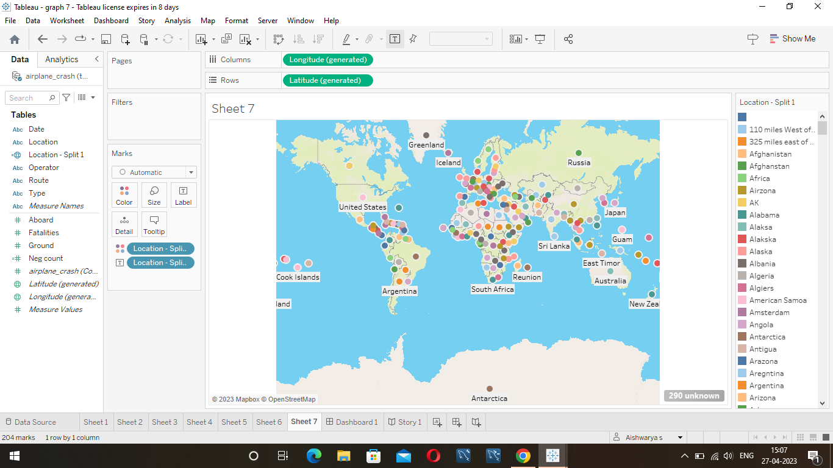

Application of airplane crash:

* Auto- drilling riveting.
* Percussive riveting.
* Pressure riveting.
* MCAS automatically swivels the horizontal tail to lift the plane’s tail while moving the nose down.
* The angle- of- attack sensor aligns itself with oncoming airflow.
* Data from the sensor is sent to the flight computer.

Conclusion:

This analysis revealed that among the pilots that caused the targeted accidents, 22 had flight experience for 301 to 1000 hours and 20 had 1001 or more hours of experience. By age, those in their 50s and 60s combined were 34, accounting for nearly 60% of the total.

Pilots with the total flight time of 301 to 1000 hours may have accumulated experience in familiarization flight recreational flight after obtaining a license and may have become confident in their skills.

Future scope:

Despite the recent tragic loss activity, flying is often said to be the safest form of transport, and this is at least true in term of fatalities per distance travelled. According to the civil aviation authority, the fatality rate per billion kilometers travelled by plane is 0.003 compared to 0.27 by rail and 2.57 by car.